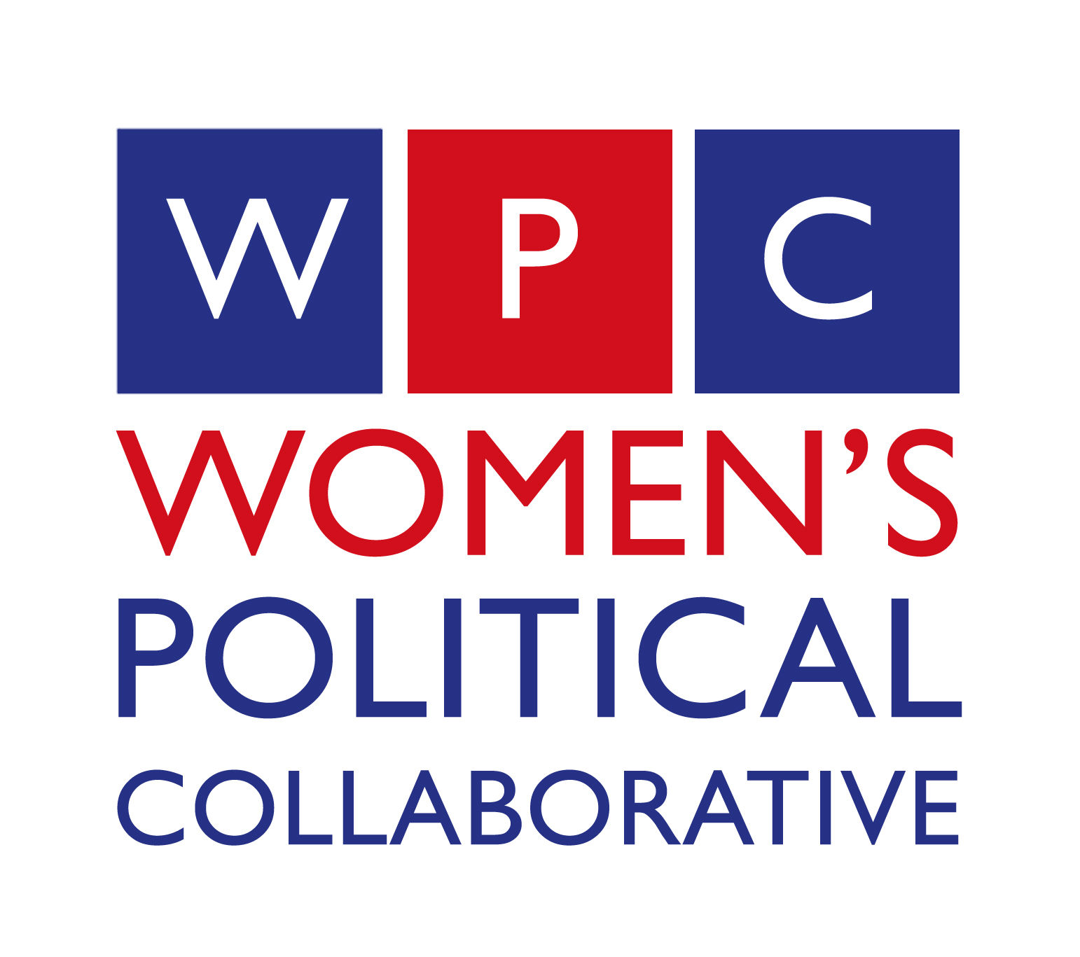
FOR IMMEDIATE RELEASE Contact: Joyce McDaniel
January 11, 2013 (615) 425.5310

Women’s Political Collaborative of Tennessee Announces ATHENA Nominees
Honoring women leaders in the Nashville community

NASHVILLE – The Women’s Political Collaborative of Tennessee announced the organizations nominees for both the ATHENA Award as well as the ATHENA Young Professionals Award.

Since 1991, the ATHENA Award and Scholarship Program has been honoring outstanding women of Nashville for their skills in business, leadership and service to their community. The program encourages women of all ages to achieve excellence, whether it be professionally, academically or personally.

“We are honored to nominate Dr. Michel McDonald for the ATHENA Award and Mary Beth Ikard for the ATHENA Young Professionals Award,” said President-Elect of WPCTN Deborah Lively. “Both women have shown great leadership and commitment to the community not only through their service to our organization but also through their professional and philanthropic endeavors.”

Dr. Michel McDonald, Assistant Professor of Medicine and Director of Dermatologic Surgery for Vanderbilt University Medical Center has served on the board of directors of the Women’s Political Collaborative of Tennessee since 2009. She is also very active in the medical community serving on many boards and associations focused on the practice of dermatology and developing a network for professional women dermatologists through a corporate grant initiative. McDonald’s commitment to the community extends outside the medical field and includes service to organization such as the Friends of Nashville Ballet, Junior League of Nashville, Renewal House and Fifty Forward.

Some of Dr. McDonald’s achievements and community activities include:
- Nashville Academy of Medicine, Chairman of the Board 2013
- Tennessee Medical Association, Board of Directors 2011-2013
- Women’s Dermatologic Society Board of Directors 2011-2014
- Tennessee Dermatology Society, President 2008
- International Society of Dermatologic Surgery, Board of Directors 2011-2015
- Women’s Political Collaborative of Tennessee, President 2013
- Friends of Nashville Ballet, President 2009-2011
- Junior League of Nashville, Chair, Advocacy and Public Awareness Committee 2004-2006
- Renewal House, Board of Directors 2003-2007
- Fifty Forward Board of Directors 2008-2012
- Nashville Emerging Leader Award in Healthcare, 2008
- Top 40 under 40 from The Tennessee, 2004
- Dermatology Education and Mentorship Award 2002 and 2006
- Golden Triangle Award from American Academy of Dermatology, 2010
Mary Beth Ikard, APR is the Communications Director for the Nashville Area MPO – a regional partnership for mobility, economic prosperity and environmental sustainability through quality investment in transportation. A Nashville native, Ikard has served the Nashville community both personally and professional for many years. Ikard’s leadership and expertise in the public relations and communications industry has made her a rising young professional in the Nashville community.

Mary Beth Ikard’s professional and community achievements include:
- League of Women Voters - Nashville Board of Directors
- Homework Hotline
- Tennessee Conservation Voters
- The Nature Conservancy – Tennessee Chapter, member of the steering committee for Generation Conservation
- Nashville Emerging Leader Award Recipient 2012
- Nashville Business Journal’s “Woman of Influence” designee, 2011
- Leadership Middle Tennessee
- Nashville Emerging Leaders
- Young Leaders Council
- Admittance to the 2012 Sewanee Writers’ Conference
The 2013 ATHENA Awards Event will be held Thursday, March 21, 2013, at the Schermerhorm Symphony Center. The program will begin at 6:00 p.m. with a reception following at 7:00 p.m. For more information about the ATHENA Awards visit www.nashvillecable.org.
The Women’s Political Collaborative of Tennessee is a non-partisan organization with the primary goal of full and equal participation of women in government and the political process at all levels. For more information visit www.wpctn.com.

